

DATA STRUCTURE AND ALOGRITHUM

Lab Report

Name: Hamza yousaf

Registration #: SEU-f16-149
Lab Report #: 06

Dated: 5-21-2018

Submitted To: Mr. Usman Ahmed

The University of Lahore, Islamabad Campus

Department of Computer Science & Information Technology

Experiment # 1

DOUBLE LINK LIST

Objective

To understand the meaninig and implementation of double link list.

Software Tool

1.

DEV C++

- Theory

Doubly Linked List is a variation of Linked list in which navigation is possible in both ways, either forward and backward easily as compared to Single Linked List. Following are the important terms to understand the concept of doubly linked list. Link Each link of a linked list can store a data called an element. Next Each link of a linked list contains a link to the next link called Next. Prev Each link of a linked list contains a link to the previous link called Prev. LinkedList A Linked List contains the connection link to the rst link called First and to the last link called Last. Doubly Linked List Representation

As per the above illustration, following are the important points to be con-sidered. Doubly Linked List contains a link element called rst and last. Each link carries a data eld(s) and two link elds called next and prev. Each link is linked with its next link using its next link. Each link is linked with its previous link using its previous link. The last link carries a link as null to mark the end of the list. Basic Operations Following are the basic operations supported by a list. 1. CREATE NEW NODE 2. ADD AT BEGINNING 3. ADD AFTER POSITIO 4. DELETE 5. DISPLAY 6. COUNT 7. REVERSE 8. QUIT

1

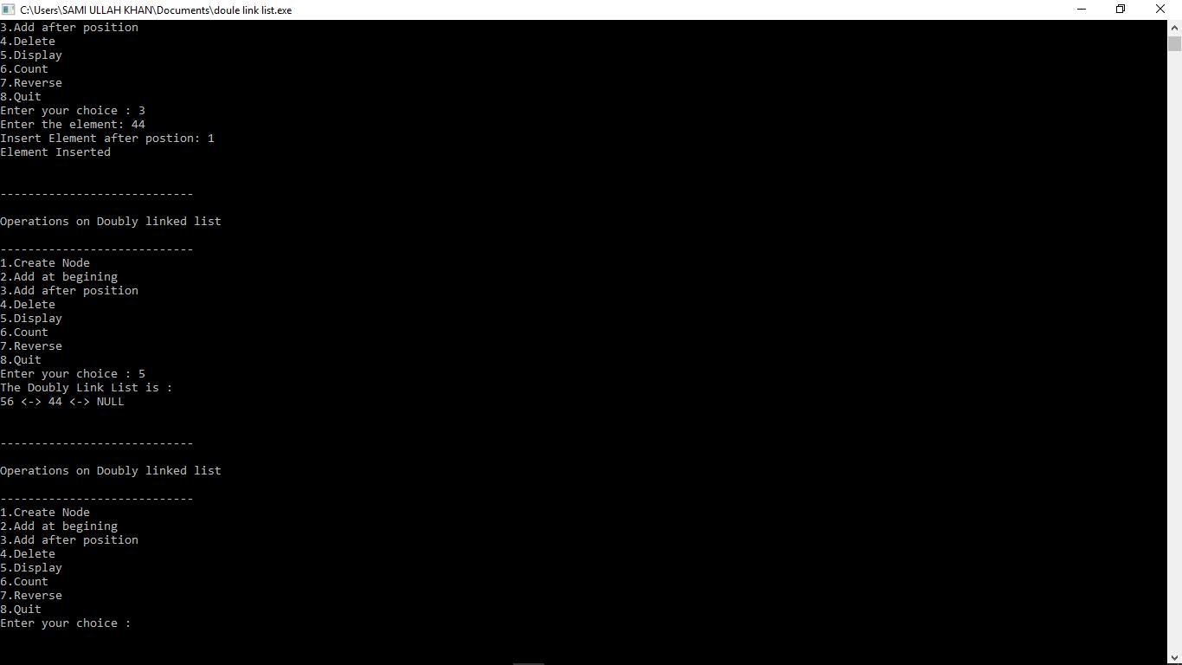

Figure 1: Time Independent Feature Set

- Task

2.1 Procedure: Task 1

The minimum number of moves required to solve a Tower of Hanoi puzzle is 2n - 1, where n is the number of disks.

#i n c l u d e <i o s t r e a m >

#i n c l u d e <c s t d i o >

#i n c l u d e <c s t d l i b >

Node D e c l a r a t i o n

/
u s i n g namespace |  | s t d ;
s t r u c t node
f
int i n f o ; |  | next ;
s t r u c t | node | next ;
s t r u c t | node | prev ;
g s t a r t ;

C l a s s D e c l a r a t i o n

2

/
c l a s s d o u b l e |  |  | l l i s t
f
p u b l i c :
v o i d |  | c r e a t e |  |  |  |  |  |  |  |  |  |  |  |  |  |  |  |  |  |  | l i s t ( int v a l u e ) ;
v o i d |  | a d d |  |  |  |  |  |  | b e g i n ( int |  |  |  |  |  |  |  |  |  |  |  |  |  |  | v a l u e ) ;
v o i d |  | a d d |  |  |  |  |  |  |  | a f t e r ( int |  |  |  |  |  |  |  |  |  |  |  |  |  | value , int p o s i t i o n ) ;
v o i d |  | d e l e t e |  |  |  |  |  |  |  |  |  |  |  |  |  |  |  |  |  | e l e m e n t ( int |  |  |  |  | v a l u e ) ;
v o i d |  | s e a r c h |  |  |  |  |  |  |  |  |  |  |  |  |  |  |  |  | e l e m e n t ( int |  |  |  |  |  | v a l u e ) ;
v o i d d i s p l a y |  |  |  |  |  |  |  |  |  |  |  |  |  |  |  |  |  |  |  |  |  |  | d l i s t ( ) ;
v o i d count ( ) ;
v o i d r e v e r s e ( ) ;
d o u b l e |  |  |  |  | l l i s t ( )
f | s t a r t = NULL;
g
g;

/

Main : Co n at in s Menu

/

int main ( )

f
int c h o i c e , element , p o s i t i o n ;

d o u b l e l l i s t d l ;

while ( 1 )

f
cout<<endl<<""<<e n d l ;
cout<<endl<<" O p e r a t i o n s |  |  |  |  |  |  |  |  | on |  | Doubly |  | l i n k e d |  | l i s t "<<e n d l ;
cout<<endl<<""<<e n d l ;
cout<<" 1 | . C r e a t e |  |  |  | Node"<<e n d l ;
cout<<" 2 | . Add |  | a t |  | b e g i n i n g "<<e n d l ;
cout<<" 3 | . Add |  | a f t e r |  |  |  | p o s i t i o n "<<e n d l ;
cout<<" 4 | . D e l e t e "<<e n d l ;

cout<<" 5 . D i s p l a y "<<e n d l ;

cout<<" 6 . Count"<<e n d l ;

cout<<" 7 . R e v e r s e "<<e n d l ;

cout<<" 8 . Quit "<<e n d l ;

cout<<" Enter your c h o i c e : " ;

c i n >>c h o i c e ;

3

s w i t c h ( c h o i c e )
f
c a s e | 1 :
 | cout<<" Enter |  |  |  |  |  |  |  |  |  |  |  |  | t h e |  |  |  |  |  | e l e m e n t : |  |  |  |  |  | " ;
 | c i n >>e l e m e n t ;
 | d l . c r e a t e |  |  |  |  |  |  |  |  | l i s t ( e l e m e n t ) ;
 | cout<<e n d l ;
 | break ;
c a s e | 2 :
 | cout<<" Enter |  |  |  |  |  |  |  |  |  |  |  |  | t h e |  |  |  |  |  | e l e m e n t : |  |  |  |  |  | " ;
 | c i n >>e l e m e n t ;
 | d l . a d d |  |  |  | b e g i n ( e l e m e n t ) ;
 | cout<<e n d l ;
 | break ;
c a s e | 3 :
 | cout<<" Enter |  |  |  |  |  |  |  |  |  |  |  |  | t h e |  |  |  |  |  | e l e m e n t : |  |  |  |  |  | " ;
 | c i n >>e l e m e n t ;
 | cout<<" I n s e r t |  |  |  |  |  |  |  |  |  |  |  |  |  |  | Element |  |  |  |  |  | a f t e r |  |  |  |  |  | p o s t i o n : |  |  |  |  |  |  |  | " ;
 | c i n >>p o s i t i o n ;
 | d l . a d d |  |  |  |  | a f t e r ( element , |  |  |  |  |  |  |  |  |  |  |  |  |  |  |  | p o s i t i o n ) ;
 | cout<<e n d l ;
 | break ;
c a s e | 4 :
 | i f ( s t a r t == NULL)
 | f
 | cout<<" L i s t |  |  |  |  |  |  |  |  |  |  |  |  |  |  |  |  | empty , n o t h i n g |  |  |  |  |  |  |  |  |  |  |  |  |  | t o |  | d e l e t e "<<e n d l ;
 | break ;
 | g
 | cout<<" Enter |  |  |  |  |  |  |  |  |  |  |  |  | t h e |  |  |  |  |  | e l e m e n t |  |  |  | f o r |  |  |  |  |  |  | d e l e t i o n : |  |  |  |  |  |  | " ;
 | c i n >>e l e m e n t ;
 | d l . d e l e t e |  |  |  |  |  |  | e l e m e n t ( e l e m e n t ) ;
 | cout<<e n d l ;
 | break ;
c a s e | 5 :
 | d l . d i s p l a y |  |  |  |  |  |  |  |  |  |  | d l i s t ( ) ;
 | cout<<e n d l ;
 | break ;
c a s e | 6 :
 | d l . count ( ) ;
 | break ;

4

c a s e | 7 :
 | i f ( s t a r t == NULL)
 | f
 | cout<<" L i s t |  | empty , n o t h i n g |  | t o |  | r e v e r s e "<<e n d l ;
 | break ;
 | g
 | d l . r e v e r s e ( ) ;
 | cout<<e n d l ;
 | break ;
c a s e | 8 :

e x i t ( 1 ) ;

d e f a u l t :

cout<<"Wrong c h o i c e "<<e n d l ;

g

g
return 0 ;

g

/

C r e a t e Double Link L i s t

/

v o i d d o u b l e l l i s t : : c r e a t e l i s t ( int v a l u e )

f
s t r u c t node s , temp ;

temp = new ( s t r u c t node ) ;

temp >i n f o = v a l u e ;

temp >next = NULL;

i f ( s t a r t == NULL)

f
temp >prev = NULL;

s t a r t = temp ;

g
e l s e

f
s = s t a r t ;

while ( s >next != NULL)

- = s >next ;

s >next = temp ; temp >prev = s ;

g

5

g
/
I n s e r t i o n a t t h e b e g i n n i n g
/
v o i d d o u b l e |  |  |  | l l i s t : : a d d |  |  |  |  | b e g i n ( int |  |  |  | v a l u e )
f
i f ( s t a r t |  |  | == NULL)
f
cout<<" F i r s t |  |  |  |  |  |  | C r e a t e |  |  |  | t h e |  | l i s t . "<<e n d l ;
return ;
g
s t r u c t node temp ;
temp = new ( s t r u c t node ) ;
temp >prev = NULL;
temp >i n f o = |  |  |  |  | v a l u e ;
temp >next = |  |  |  |  | s t a r t ;

s t a r t >prev = temp ;

s t a r t = temp ;

cout<<" Element I n s e r t e d "<<e n d l ;

g

I n s e r t i o n o f e l e m e n t a t a p a r t i c u l a r p o s i t i o n

/
v o i d d o u b l e |  |  |  |  | l l i s t : : a d d |  |  |  |  | a f t e r ( int |  |  |  | value , int pos )
f
i f | ( s t a r t |  |  | == NULL)
f | cout<<" F i r s t |  |  |  |  |  |  | C r e a t e |  |  |  | t h e |  | l i s t . "<<e n d l ;
g | return ;
g |  |  |  |  |  | tmp , |  | q ;
s t r u c t node
int | i ;
q = | s t a r t ; |  |  |  |  |  |  |  | 1 ; i ++)
for | ( i = |  |  | 0 ; i |  | < pos
f

- = q >next ;

i f ( q == NULL)

f

6

cout<<" There a r e l e s s than " ;

cout<<pos<<" e l e m e n t s . "<<e n d l ;

return ;

g

g
tmp = new ( s t r u c t node ) ;

tmp >i n f o = v a l u e ;

i f ( q >next == NULL)

f
q >next = tmp ;

tmp >next = NULL;

tmp >prev = q ;

g
e l s e

f
tmp >next = q >next ;

tmp >next >prev = tmp ;

q >next = tmp ;

tmp >prev = q ;

g
cout<<" Element I n s e r t e d "<<e n d l ;

g

D e l e t i o n o f e l e m e n t from t h e l i s t

/

v o i d d o u b l e l l i s t : : d e l e t e e l e m e n t ( int v a l u e )

f
s t r u c t node tmp , q ;

/ f i r s t e l e m e n t d e l e t i o n /

i f ( s t a r t >i n f o == v a l u e )

f
tmp = s t a r t ;

s t a r t = s t a r t >next ;

s t a r t >prev = NULL;

cout<<" Element D e l e t e d "<<e n d l ;

f r e e ( tmp ) ;

return ;

g
q = s t a r t ;

7

while ( q >next >next != NULL)

f
/ Element d e l e t e d in between /

i f ( q >next >i n f o == v a l u e )

f
tmp = q >next ;

q >next = tmp >next ;

tmp >next >prev = q ;

cout<<" Element D e l e t e d "<<e n d l ;

f r e e ( tmp ) ;

return ;

g
- = q >next ;

g
/ l a s t e l e m e n t d e l e t e d /

i f ( q >next >i n f o == v a l u e )

f
tmp = q >next ;

f r e e ( tmp ) ;

q >next = NULL;

cout<<" Element D e l e t e d "<<e n d l ;

return ;

g
cout<<" Element "<<value<<" not found "<<e n d l ;

g
/
D i s p l a y e l e m e n t s o f |  |  |  |  |  |  |  |  |  |  |  | Doubly Link |  |  |  |  |  |  |  |  |  |  |  |  |  |  |  |  |  |  |  |  |  | L i s t
/
v o i d d o u b l e |  |  | l l i s t : : d i s p l a y |  |  |  |  |  |  |  |  |  |  |  |  |  |  |  |  | d l i s t ( )
f |  |  |  |  |  |  | q ;
s t r u c t node
i f | ( s t a r t == NULL)
f | cout<<" L i s t |  |  |  |  |  |  |  | empty , n o t h i n g |  |  |  |  |  |  |  |  |  |  |  |  |  |  |  |  |  |  |  |  | t o |  |  |  |  |  |  |  | d i s p l a y "<<e n d l ;
g | return ;
q | = s t a r t ;
cout<<"The |  |  |  |  |  |  | Doubly |  |  |  |  | Link |  |  |  |  |  | L i s t |  |  |  |  |  | i s |  |  |  |  |  |  |  |  |  | : "<<e n d l ;
while ( q != NULL)

8

f
cout<<q >i n f o <<" < > " ;

- = q >next ;

g
cout<<"NULL"<<e n d l ;

g

Number o f e l e m e n t s in Doubly Link L i s t

/

v o i d d o u b l e l l i s t : : count ( )

f
s t r u c t node q = s t a r t ;

int c n t = 0 ;

while ( q != NULL)

f

- = q >next ; c n t++;

g
cout<<"Number o f e l e m e n t s a r e : "<<cnt<<e n d l ;

g

R e v e r s e Doubly Link L i s t

/

v o i d d o u b l e l l i s t : : r e v e r s e ( )

f
s t r u c t node p1 , p2 ;

p1 = s t a r t ;

p2 = p1 >next ;

p1 >next = NULL;

p1 >prev = p2 ;

while ( p2 != NULL)

f
p2 >prev = p2 >next ;

p2 >next = p1 ;

p1 = p2 ;

p2 = p2 >prev ;

g
s t a r t = p1 ;

9

cout<<" L i s t Reversed "<<e n d l ;

g

- Conclusion

in this lab we perform the basics function of double link list insertion deletion insertion at any n postion display reverse etc

10

